ORIENTATION AND PAGE SETUP
This section will discuss how to adjust our page and the document’s orientation according to our requirement.

Formatting Paragraphs
Word creates a new paragraph each time you press the Enter key. We can format paragraphs. Paragraph formatting includes indenting the first line of a paragraph, setting the amount of space that separates paragraphs, and aligning a paragraph left, right, center, or flush with both margins. We can quickly apply a set of formats called “styles” to a paragraph. Applying a style refers to, setting the font, font size, and aligning a paragraph all at once. In this chapter, paragraph formatting and the different styles we can apply to a paragraph.
To format a paragraph, place the cursor anywhere in the paragraph. After formatting, press the Enter key to create a new paragraph in the same format.

Changing Line Spacing
Line spacing determines the amount of space between lines within a paragraph. The spacing for each line is set so that it can accommodate the largest font on that line. Smaller fonts will appear to be extra space between lines. To change the line spacing we place cursor anywhere in the paragraph. In the Home tab click the Line Spacing button in the Paragraph group and select the desired line spacing.


Creating a First-Line Indent
To indent the first line of paragraphs, we use the Paragraph dialog box to set the amount by which we want to indent. In the Special field of the Paragraph dialog box, choose First Line from the menu options. In the By field, choose the amount in inches by which we want to indent.

Indenting Paragraphs
We can indent our paragraph from the left and/or right margin. This is required for quoting a large block of text. To indent a paragraph 1” from each side (for example) we place the cursor anywhere in the paragraph. In the Page Layout tab select 1" in the Indent Left field and Indent Right field either by typing or by using arrows. This indents the paragraph one inch from both the left and right margins.

Aligning Paragraphs
Several types of alignment choices are available in Microsoft Word. Left-aligned text is flush with the left margin of document (the default setting). Right-aligned text is flush with the right margin of document, centered text is centered between the left and right margins, and Justified text is flush with both the left and right margins. Alignment options are there in the Paragraph menu of Home tab. Alternatively, we can use some keyboard shortcuts for aligning paragraphs.
The shortcuts are listed in table
ALLIGNMENT | SHORTCUT
Right alignment | Ctrl +r
Left alignment | Ctrl +l
Centered | Ctrl +e
Justified | Ctrl +j

Displaying A Document In Different Ways
Word provides several ways to view a document: normal view, outline view, page layout view and print preview.

Normal View: For Typing and Editing
Normal view_ the preset view in Word_ shows a simplified version of a document. It’s the best all purpose view for typing, editing, and formatting text, and for moving around in a document. To switch to normal view, choose Normal from the View menu.

Outline View: For Outlining and Organizing A Document
In outline view, we can collapse a document to see only the main headings or expand it to see the entire document. This view makes it easy to scroll or move text a long distance or to change the hierarchy of topics. To switch to outline view, choose Outline from the View menu.

Page Layout View: For Seeing the Printed Page
This view is useful for checking the final appearance of a document. To switch to Page Layout view, choose Page Layout from the View menu.

Print Preview: For Adjusting the Layout before Printing
Print preview shows the entire pages at a reduced size, so we can adjust the document’s layout before printing. We can see one or more pages at a time, zoom in or out, adjust margins, and edit and format text. To switch to print preview, choose Print Preview from the File menu.
- We can use a combination of views to work more efficiently. For example, we can switch between Normal and Outline views, using normal view to do detailed work and outline view to do larger organizational tasks.

Page Setup

Setting the Orientation
Before printing our document we can use one of these two orientations
* Portrait
*landscape
In Portrait, the shortest edge of the paper becomes the top of the page. Portrait is the default option.
Portrait
In Landscape, the longest edge of the paper becomes the top of the page
Landscape
To set the orientation we click Orientation in the Page Setup group (Page Layout tab).
Then choose any one of Portrait or Landscape.
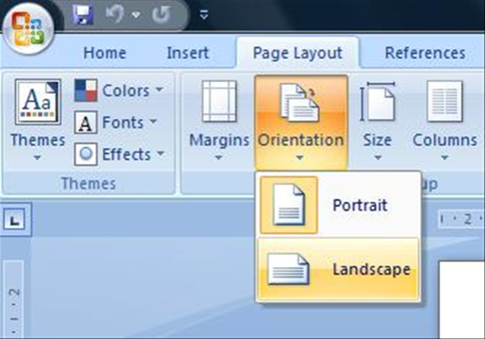

Setting the Margins
Margins define the amount of white space at the top, bottom, left, and right edges of document. We can choose several standard margin sizes from the Margin option in the Page Setup group (Page Layout tab).

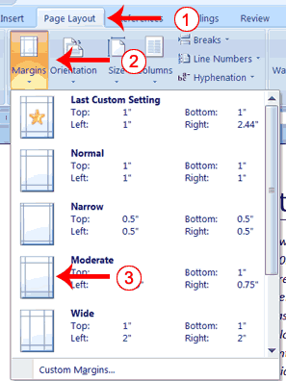

Setting the Page Size
Paper comes in a variety of sizes. The default page size in Word is 8 1/2 by 11. To set the paper size we click Size in the Page Setup group (Page Layout tab) and select the desired size.
